**Q2. Using Packet Tracer, simulate an ARP spoofing attack. Analyze the behavior of devices on the network when they receive a malicious ARP response.**

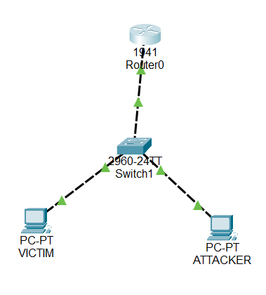

**Using ping command in victim’s PC to the router:**

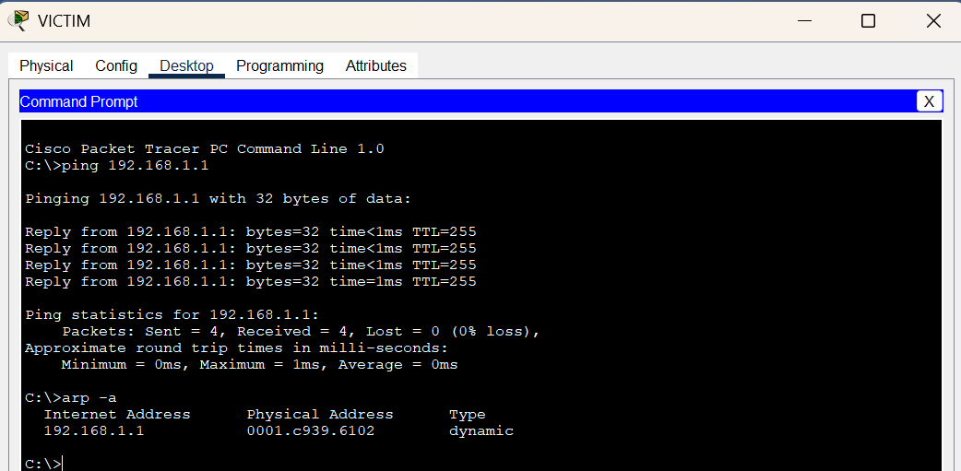

**Changing the MAC address of the router to the MAC address of the attacker :**

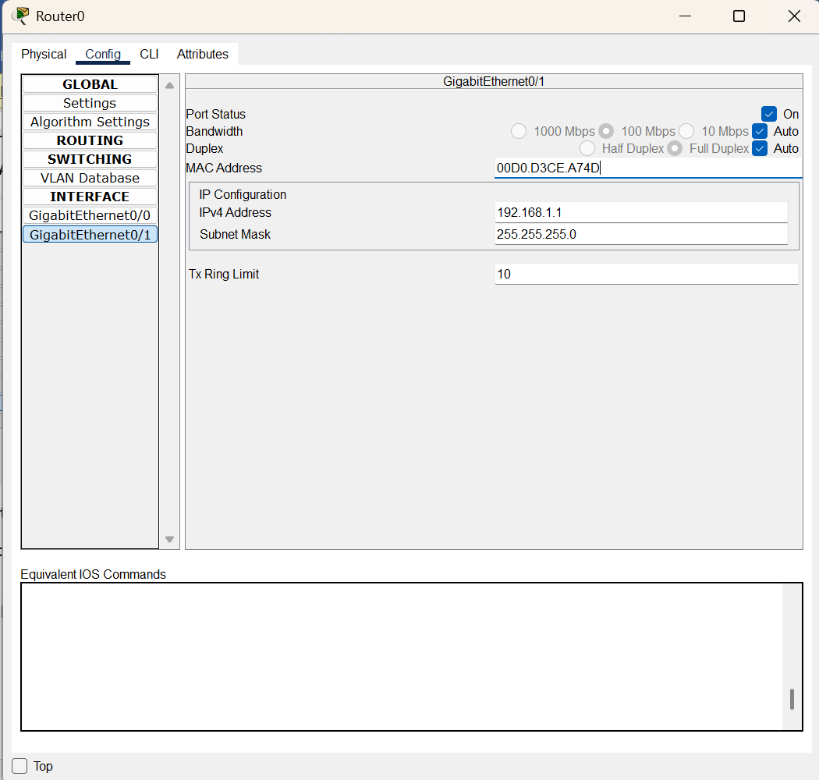

**Updation of the arp table:**

